**Happenings Week of June 15th, 2025**

**Tuesday/ Martes June 17th / Junio 17th**

8;30 AM NO Mass

7:00 PM AA/Al-Anon (RE Center)

**Wednesday/ Miercoles –June 18th / Junio 18th**

10:00 AM-12:00 PM Food Pantry/Despensa de Alimentos (Social Hall)

**Thursday/ Jueves – June 20th / Junio 20th**

1:00 – 3:00 PM Crafts (Social Hall)

5:30 PM NO MASS

6:00 PM Adoration

**Sunday/ Domingo June 22nd/ Junio 22nd**

10:30 AM – Mass

5:30 PM – Mass- Spanish

St. Patrick

1405 N. Federal, Hampton 641-456-4857

Office Hours: Monday through Thursday

9:00 AM-1:00 PM, excluding holidays.

dbq097sec@dbqarch.org

***Liturgical Ministries***

**June 22nd, 2025 – Junio 22nd, 2025**

**Mass—June 22nd, 2025 10:30 a.m.**

Lector: Maggie Pearson

Ushers: Madonna Weiland, Trace Brocka

Eucharistic Ministers; Dean & Samantha Markwardt

Money Counters: Millicent Fielding, Sue Basye

Altar Servers: Bella & Alondra Duran, Yamilla Fuentes

Sacristan: Maria Alonzo

Linens: Maria Alonzo

**Spanish Mass– Junio 22nd, 2025 5:30 p.m**

Lector: Elbia Troches, Anabel Alanis

Ministros de Eucarísticos: Estenia Madrid, Jose Franco

Contador es de Dinero: Rafael Garcia, Sheyla Soto

Monaguillos: Justin Guillen, Ayleen Rodrigue, Liam Rodriguez

Sacristan: Brenda Diosdado

**You are responsible to find your own replacement.**

**Usted es responsable de encontrar su propio reemplazo.**

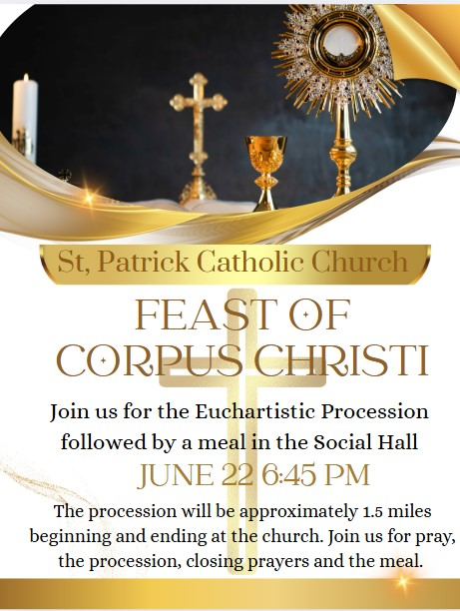

Anuncios meteorológicos



**STEWARDSHIP TREASURY**

**SUNDAY JUNE 8th, 2025**

**REGULAR $ 3,125.00**

**OFFERTORY $ 191.00**

**BUILDINGS & GROUNDS $ 25.00**

**FOOD PANTRY $ 75.00**

**Give On-Line at** [**www.franklinhardincatholic.org**](http://www.franklinhardincatholic.org) **online-giving.**

**Dona en línea para www.franklinhardincatholic.org donaciones en línea.**

